8 BIT DIVISION

EXP NO: 4

AIM : To write an assembly language program to implement 8 bit division using 8085 processor

ALGORITHM:

1. Start the program by loading the first data into the accumulator.
2. Move the data to a register.
3. Get the second data and load int the accumulator.
4. Add the two register content.
5. Check for carry .
6. Store the value of sum and carry in the memory location.
7. Halt.

PROGRAM

LDA 8500

MOV B,A

LDA 8501

MVI C,00

LOOP: CMP B

JC LOOP1

SUB B

INR C

JMP LOOP

LOOP1: STA 8502

MOV A,C

STA 8503

RST 1

INPUT:

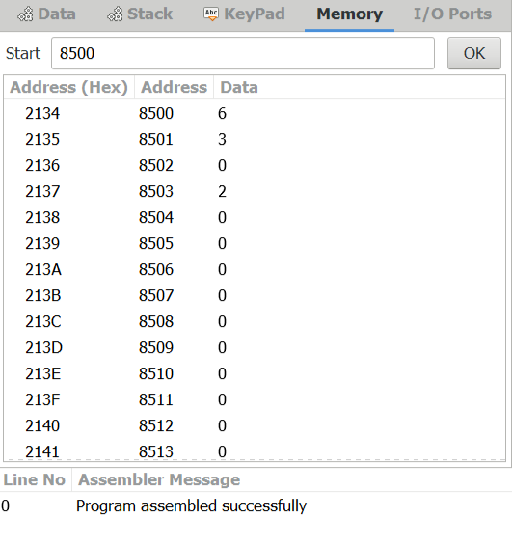

OUTPUT:

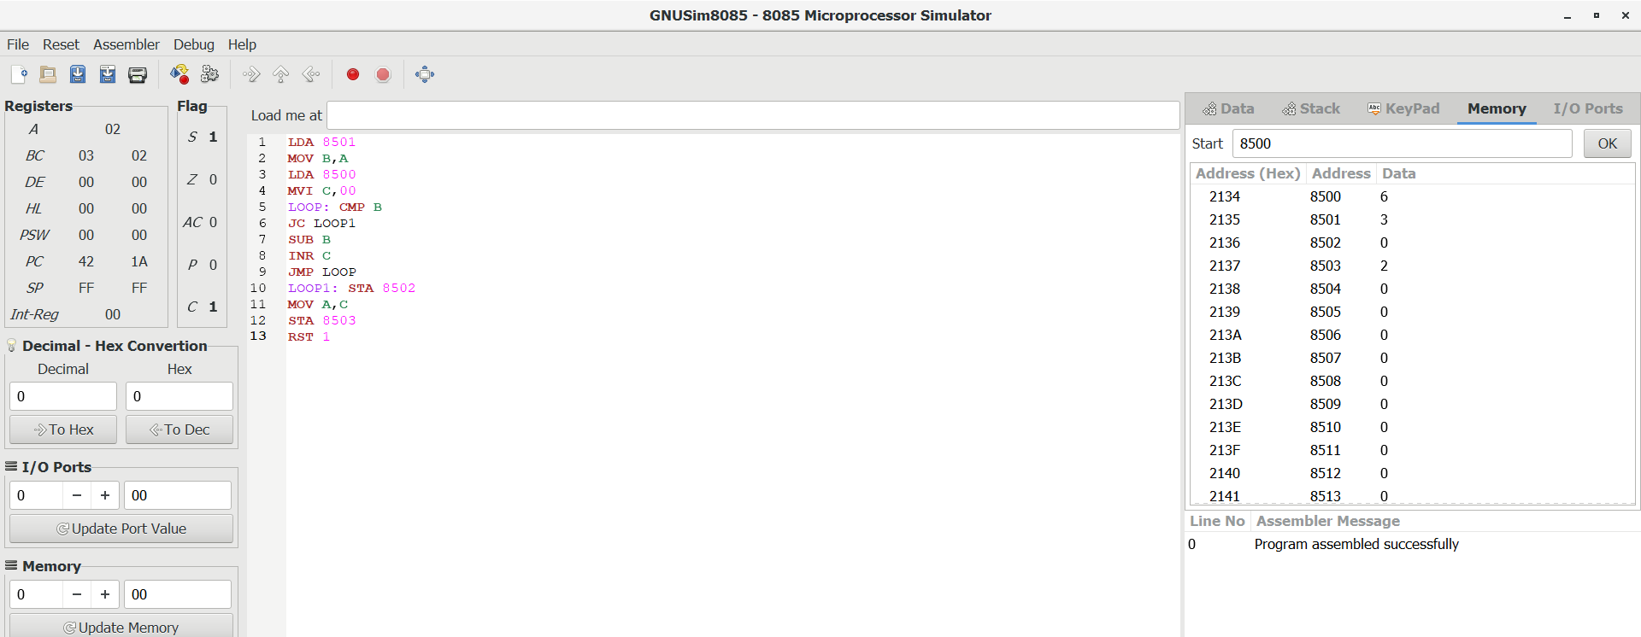

RESULT:

Thus the program was executed successfully using 8085 processor simulator.